
Work Instruction for Cisco RMA Return

Viatris
Work Instruction for
Cisco RMA Return

Contents
Contents 2
1. Introduction 3
1.1. Purpose 3
1.2. Scope of this Report 3
1.3. Audience 3
2. Approach and Methodology 3
2.1 Approach 3
2.2 Methodology 3
3. Technical Details 3
3.1. step 1 3
3.2. Step 2 5
3.3. Step 3 6
4. Roles and Responsibilities 7
5. Escalation Matrix 8
6. Related Documentation 8
6.1. Additional Documentation 8
7. Revision History 8

1. Introduction

1.1. Purpose
This document will provide the procedure to be followed while Cisco RMA Return for the faulty parts

1.2. Scope of this Report
The purpose of this guide is to provide details on Cisco RMA Return.

1.3. Audience
GIDC UNIX Group

2. Approach and Methodology

2.1 Approach

2.2 Methodology
2.2.1. Login to cisco global return with username and password. Search the RMA number, click request return and mention the contact information.
2.2.2. Schedule the pickup.
2.2.3. Submit the request, get the label print, and open the RITM to IT facilities team to create the outbound request.

3. Technical Details

3.1. step 1
Login to cisco global return and login with username and password.
Search the RMA no and click request return
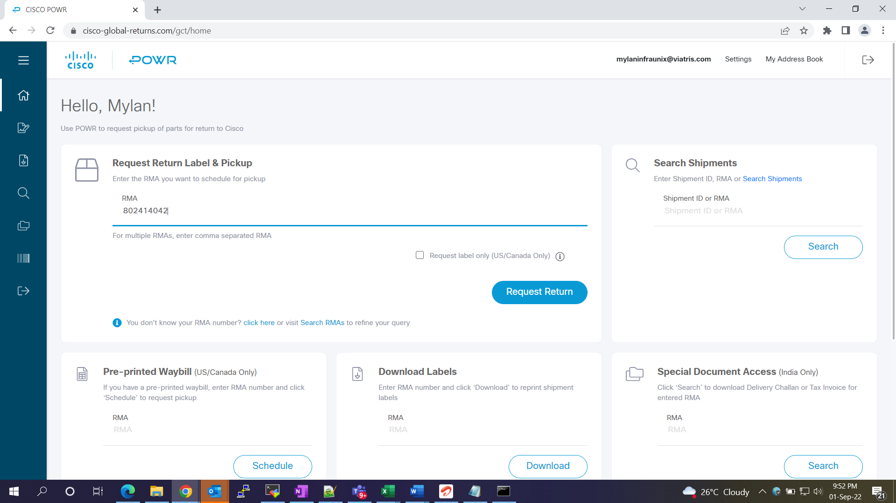
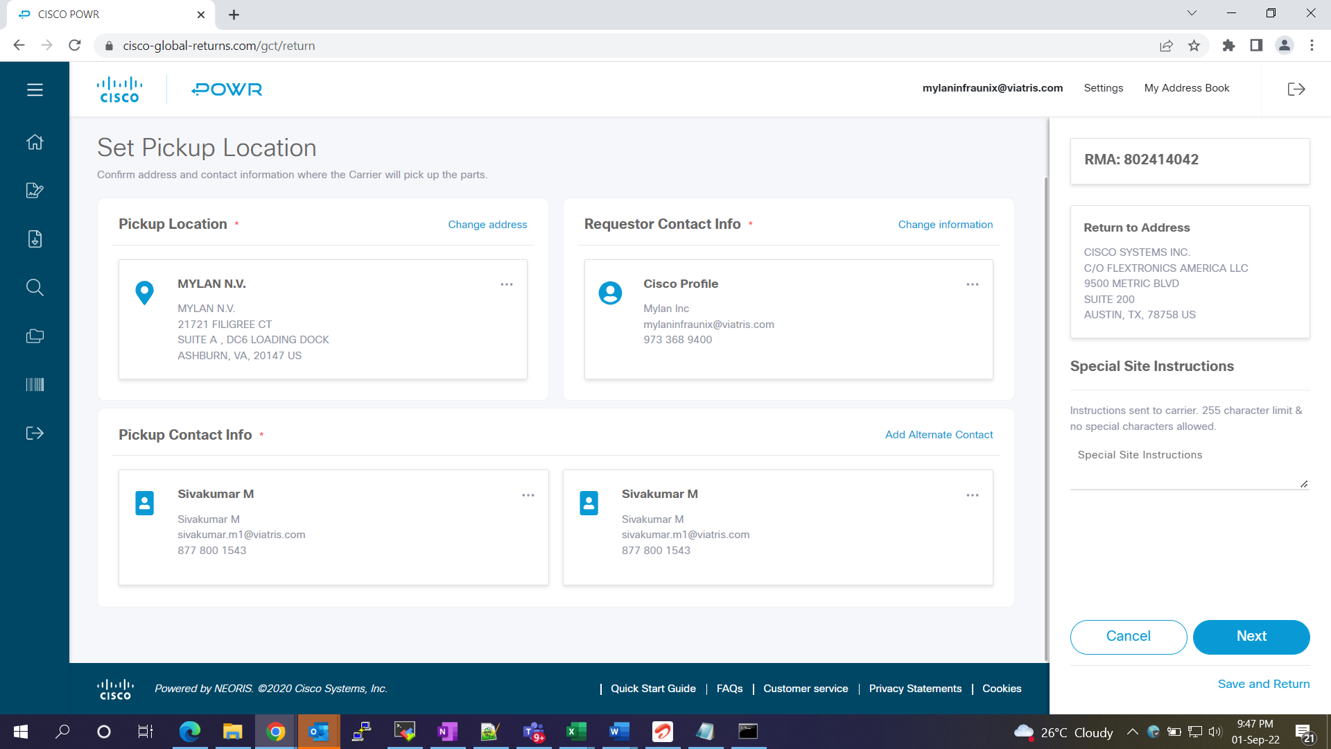
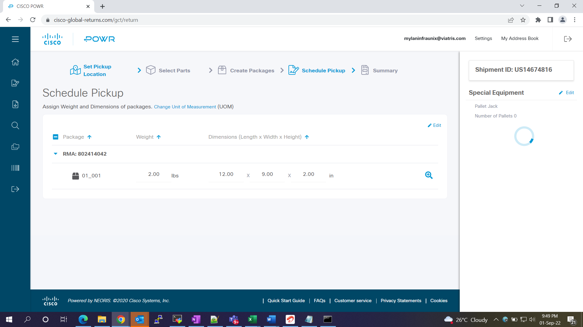

3.2. Step 2
Schedule the pickup.
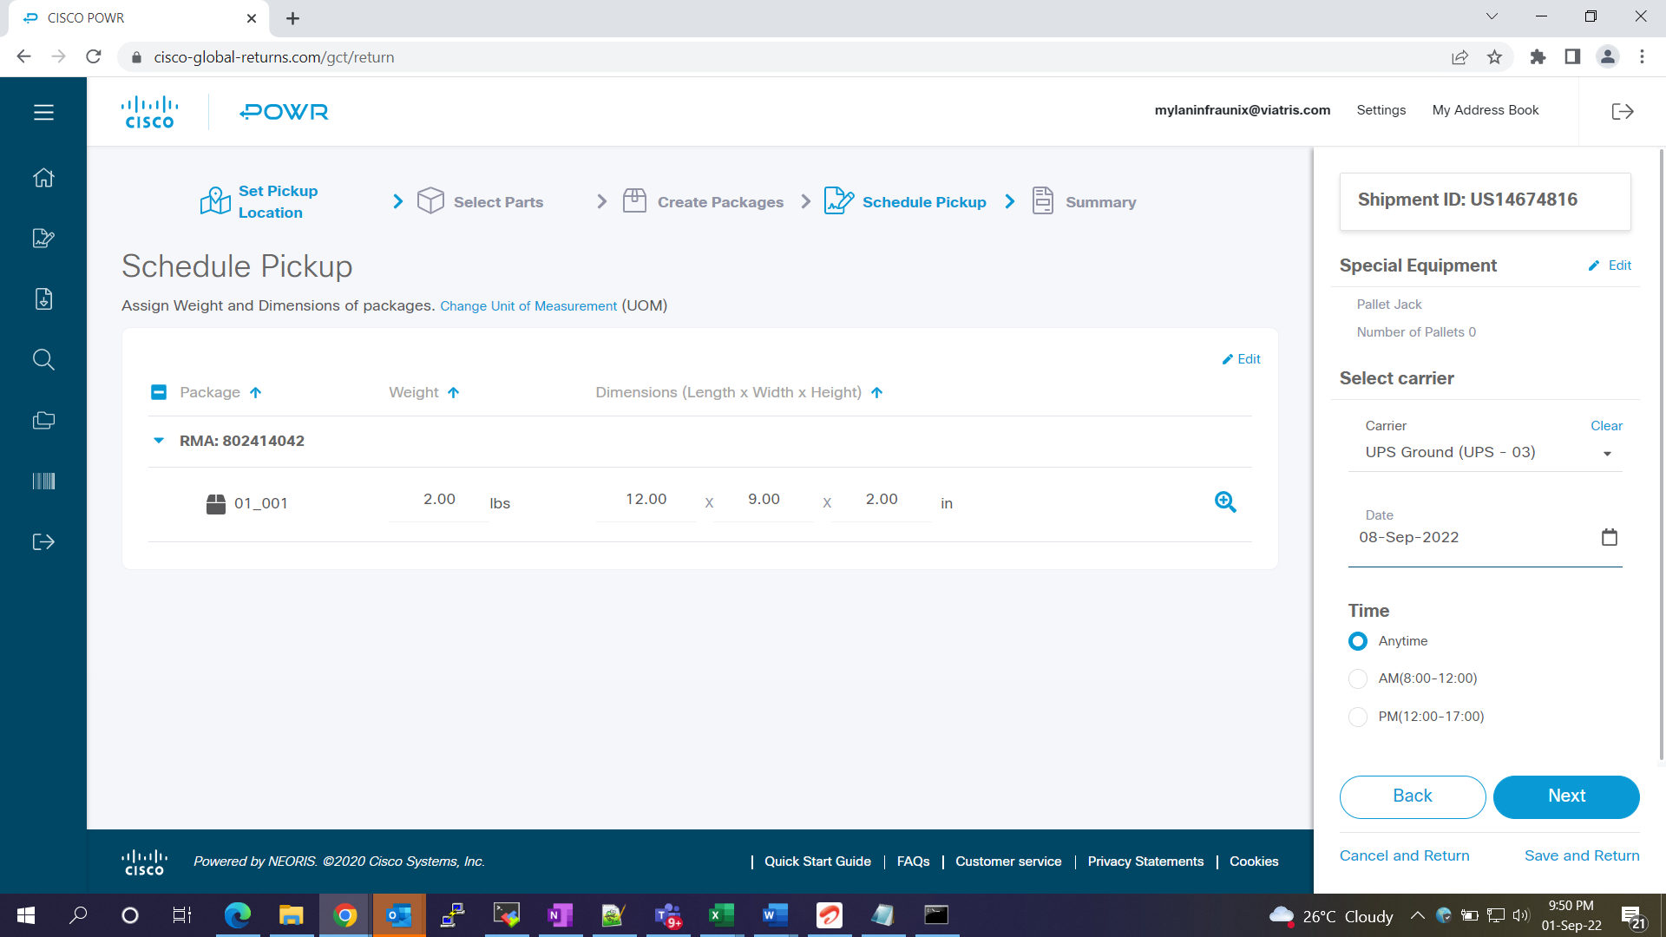

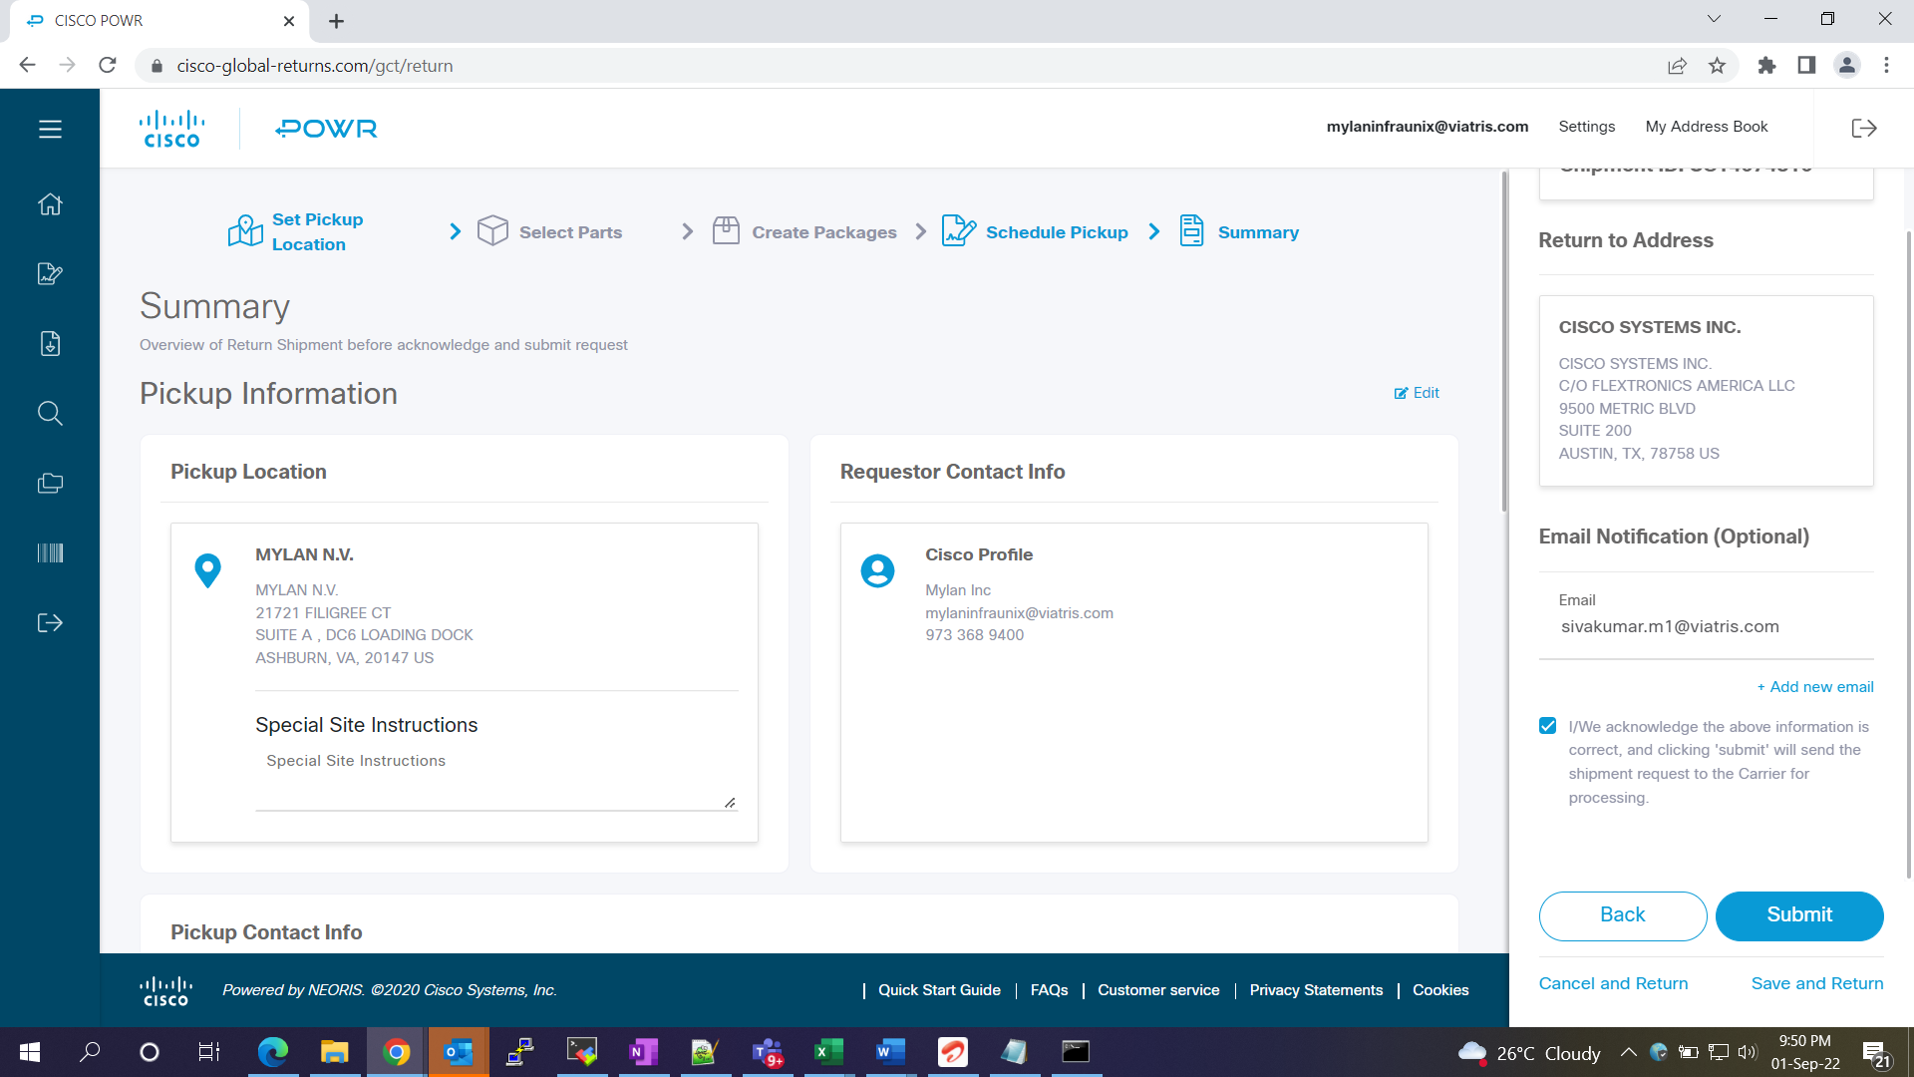

3.3. Step 3
Submit the request
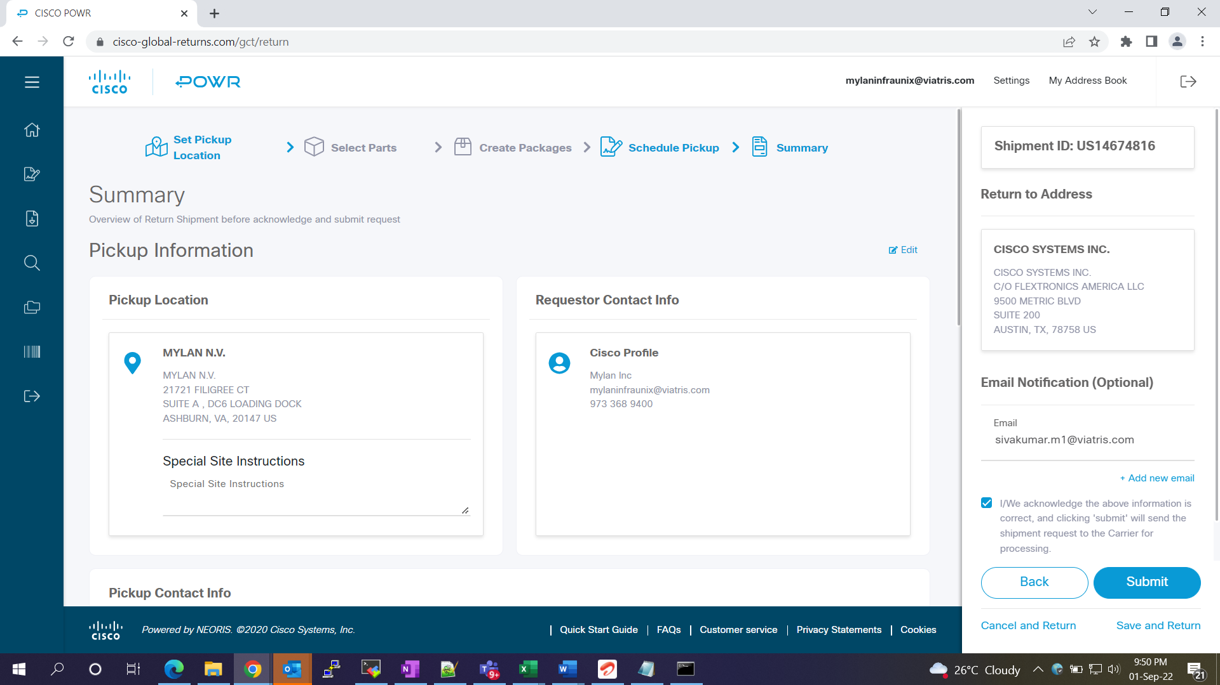

Get the label print and open the RITM to IT facilities team to create the outbound request.
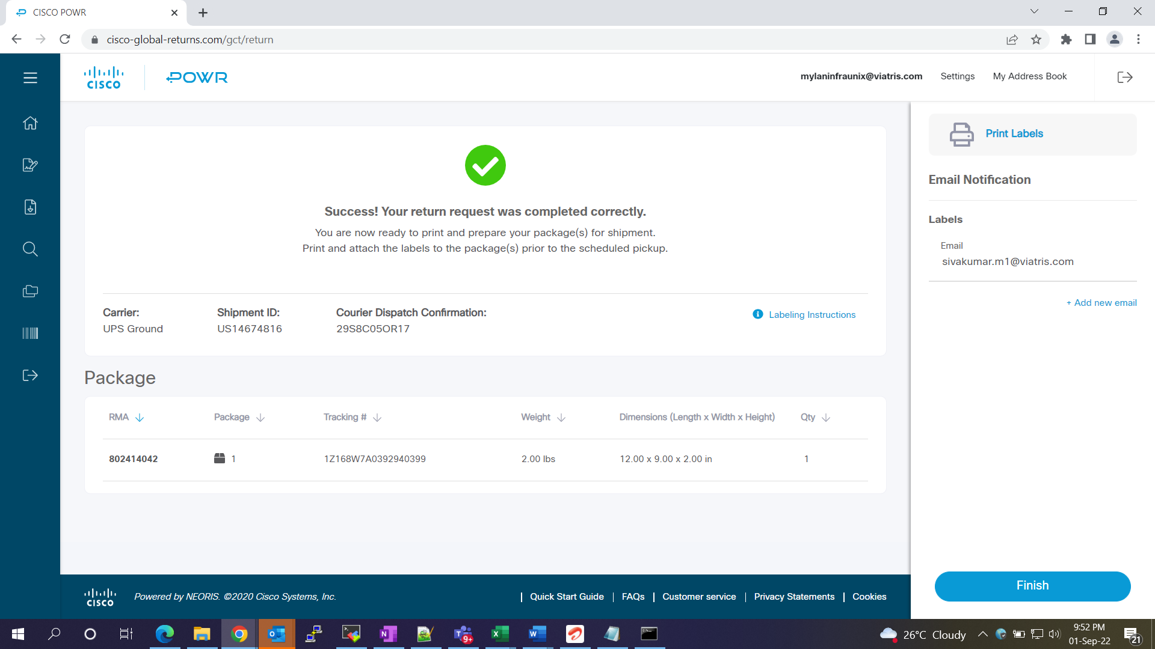

4. Roles and Responsibilities
Sl. No. | Roles | Responsibilities | Team Member Name
1. | Maintenance Window | Respective Team / Unix Team | GIDC.unix_Run  GIDC.unix_Run@viatris.com
2. | Change Request | Respective Team / Unix Team | GIDC.unix_Run  GIDC.unix_Run@viatris.com
3. | Change Implementation | Respective Team / Unix Team | GIDC.unix_Run  GIDC.unix_Run@viatris.com
4. | Hyper Care | Respective Team / Unix Team | GIDC.unix_Run  GIDC.unix_Run@viatris.com

5. Escalation Matrix
Person Responsible | Role | Triggers When
Arun R  Arun.R@viatris.com  +91 9710677240 | SME
Ashok Kumar R K  AshokKumar.RK@viatris.com  +91 9967735890 | Manager
Mohandoss Murugesan  Mohandoss.Murugesan@viatris.com  +91 6366966170 | Senior Manager

6. Related Documentation

6.1. Additional Documentation

7. Revision History
Date | Version | Summary of Changes | Author | Approved by
May 19 2021 | V1.0 | Updated Organization Detail | Franklin Kabila Dhas | Arunachalam G
Apr 5 2023 | V1.1 | Updated in New Template | Ashok Kumar RK | Mohandoss Murugesan
Dec 28 2024 | V1.2 | Validated the Document | Benesh Selva Nesan P | Arun R

